FML : Assignment 01 Report



Department of Computer Science

Indian Institute of Technology Bombay

Guided by

**Prof. Sunita Sarawagi**

**Foundation of Machine Learning**

**CS 725**

Prepared By

**Bharat Patidar**

**23M0761**

**Rohit Singh Yadav**

**23M0773**

# Report :

In this Exercise/Assignment we have learnt the training of Logistic Regression Model and Linear Classification Model.

The optimal value of accuracy depends on the following three parameters.

1. Learning Rate

2. Epochs

3. Momentum

The below table states the different parameter value for optimal accuracy :

|  |  |  |
| --- | --- | --- |
|  | Logistic Regression | Linear Classification |
| Learning Rate | 0.1 | 0.1 |
| Epochs | 1000 | 250 |
| Momentum | 0.9 | 0 |
| Accuracy(%) | 85.33% | 96% |
| Loss | 4.35 | 7.65 |

# Report of Logistic Regression

In the Logistic Regression Model the Dataset is taken from <https://github.com/ashutoshbsathe/cs725-hw> . In this model the binary dataset is used where the number of classes were 2 also the number of features of dataset is also 2.

We have implemented functions : calculate_loss(), calculate_gradient(), update_weights() and get_prediction() functions. Also implemeted preprocess() and sigmoid() functions for model training purpose.

In this report we have to analyse the effect of the three parameters on the model’s accuracy and loss. As the parameters are :

1. Learning Rate

2. Epochs

3. Momentum

**Effect of Learning Rate on Loss and Accuracy :**

As the Learning rate of the model increases the step size or the gradient loss increases hence , the rate of change of learning rate directly affects the accuracy . Also the epochs is also a important parameter while finding the effeicient value of learning rate.

As in the calculation we have taken the epochs as 100 initially for calculating learning rate.

# Epochs = 100

Momentum = 0

|  |  |  |
| --- | --- | --- |
| Learning Rate | Accuracy (%) | Loss |
| 1e-1 | 82.67% | 2.25 |
| 1e-2 | 77.33% | 0.91 |
| 1e-4 | 77.33% | 0.69 |
| 1e-6 | 77.33% | 0.69 |

**Conclusion :**

As the Accuracy is most optimal when we use Learning Rate = 1e-1 = 0.1 . As we decrease the size of the Learning Rate alpha the accuracy decreases . But with the decrease in learning rate the loss also decreases.

Hence , the most efficient Learning Rate is 0.1 as it gives the accuracy 82.67%.

**Effect of # of Epochs on Loss and Accuracy :**

As the Epochs of the model increases the number of iterations increases . hence , the rate of change of Epochs directly affects the accuracy . # of Epochs states that how much time the model will search for the minima or in search of valley the model will how much effort. Also the epochs is also a important parameter while finding the effeicient value of learning rate.

As in the calculation we have taken the Learning Rate as .0.1 for calculating # of Epochs.

Learning Rate = .0.1

Momentum = 0

|  |  |  |
| --- | --- | --- |
| # of Epochs | Accuracy (%) | Loss |
| 100 | 82.67% | 2.25 |
| 250 | 84% | 3.03 |
| 500 | 84% | 3.66 |
| 1000 | 85.33% | 4.35 |

**Conclusion :**

As the Accuracy is most optimal when we use Learning Rate = 1e-1 = 0.1 and use the # of Epochs = 1000 . As we increase the number of the Epochs the accuracy increases . But the increase in the Epochs causes the increase in loss.

Hence , the most efficient Learning Rate is 0.1 and Number of Epochs is 1000.

**Effect of Momentum on Loss and Accuracy :**

As the Momentum states that gradients accumulated from past iterations will push the cost further to move around a saddle point even when the current gradient is negligible or zero. It is better when we use gradient descent .

As in the calculation we have taken the Learning Rate as 0.1 And # of Epochs 1000 for calculating # of Epochs.

Learning Rate = 0.1

# of Epochs = 1000

|  |  |  |
| --- | --- | --- |
| Momentum | Accuracy(%) | Loss |
| 0 | 85.33% | 4.35 |
| 0.9 | 85.33% | 4.35 |

**Conclusion :**

As the Accuracy is most optimal when we use Learning Rate = 1e-1 = 0.1 and use the # of Epochs = 1000 . As we increase the momentum the accuracy increases . But the increase in the Momentum causes the increase in loss.

Hence , the most efficient Learning Rate is 0.1 and Number of Epochs is 1000 and Momentum is 0.9 .

**Graph :**

Learning Rate = 0.1

# of Epochs = 250

Momentum = 0

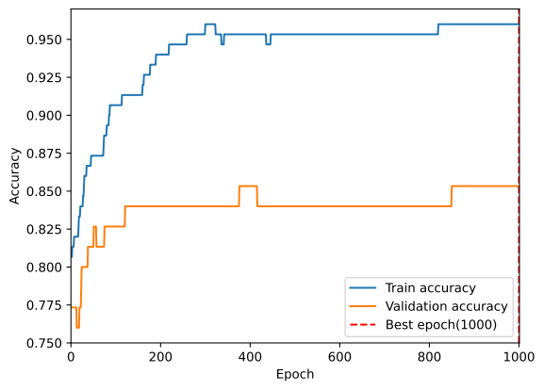

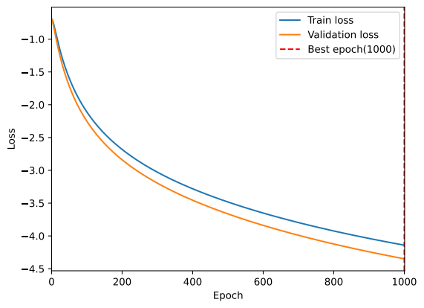

# Report of Linear Classifier

In the Linear Classifier Model the Dataset is taken from <https://github.com/ashutoshbsathe/cs725-hw> . In this model the Iris dataset is used where the number of classes were 3 also the number of features of dataset is also 4.

We have implemented functions : calculate_loss(), calculate_gradient(), update_weights() and get_prediction() functions. Also implemeted preprocess() and sigmoid() functions for model training purpose.

In this report we have to analyse the effect of the three parameters on the model’s accuracy and loss. As the parameters are :

1. Learning Rate

2. Epochs

3. Momentum

**Effect of Learning Rate on Loss and Accuracy :**

As the Learning rate of the model increases the step size or the gradient loss increases hence , the rate of change of learning rate directly affects the accuracy . Also the epochs is also a important parameter while finding the effeicient value of learning rate.

As in the calculation we have taken the epochs as 100 initially for calculating learning rate.

# Epochs = 100

Momentum = 0

|  |  |  |
| --- | --- | --- |
| Learning Rate | Accuracy (%) | Loss |
| 1e-1 | 96% | 6.23 |
| 1e-2 | 80% | 4.10 |
| 1e-4 | 40% | 2.56 |
| 1e-6 | 40% | 2.41 |

**Conclusion :**

As the Accuracy is most optimal when we use Learning Rate = 1e-1 = 0.1 . As we decrease the size of the Learning Rate alpha the accuracy decreases . But with the decrease in learning rate the loss also decreases.

Hence , the most efficient Learning Rate is **0.1**

**Effect of # of Epochs on Loss and Accuracy :**

As the Epochs of the model increases the number of iterations increases . hence , the rate of change of Epochs directly affects the accuracy . # of Epochs states that how much time the model will search for the minima or in search of valley the model will how much effort. Also the epochs is also a important parameter while finding the effeicient value of learning rate.

As in the calculation we have taken the Learning Rate as 0.1 for calculating # of Epochs.

Learning Rate = 0.1

Momentum = 0

|  |  |  |
| --- | --- | --- |
| # of Epochs | Accuracy (%) | Loss |
| 100 | 96% | 6.23 |
| 250 | 100% | 7.65 |
| 500 | 100% | 11.23 |
| 1000 | 100% | 13.26 |

**Conclusion :**

As the Accuracy is most optimal when we use Learning Rate = 1e-1 = 0.1 and use the # of Epochs = 250 . As we increase the number of the Epochs the accuracy increases . But after a thresold value the accuracy remains constant. But the increase in the Epochs causes the increase in loss.

Hence , the most efficient Learning Rate is 0.1 and Number of Epochs is 250.

**Effect of Momentum on Loss and Accuracy :**

As the Momentum states that gradients accumulated from past iterations will push the cost further to move around a saddle point even when the current gradient is negligible or zero. It is better when we use gradient descent .

As in the calculation we have taken the Learning Rate as 0.1 And # of Epochs 250 for calculating Momentum.

Learning Rate = 0.1

# of Epochs = 250

|  |  |  |
| --- | --- | --- |
| Momentum | Accuracy(%) | Loss |
| 0 | 100% | 7.65 |
| 0.9 | 100% | 13.53 |

**Conclusion :**

As the Accuracy is most optimal when we use Learning Rate = 1e-1 = 0.1 and use the # of Epochs = 250 . As we increase the momentum the accuracy increases . But the increase in the Momentum causes the increase in loss.

Hence , the most efficient Learning Rate is 0.1 and Number of Epochs is 250 and Momentum is 0.

**Graph :**

Learning Rate = 0.1

# of Epochs = 250

Momentum = 0

